**1.What is the size of MBR and what does it contains?**

**Ans:** The MBR (Master Boot Record) is 512 bytes.

* 1. 446 bytes Bootloader
  2. 64 bytes (4 * 16 bytes) Partition Table
  3. 2 bytes Magic Number which is AA55H
* Back to old days MBR was used to load kernel into memory and to bootstrap it. Nowadays MBR used to bootstrap bootloaders, then bootloaders bootstraping kernel.
* The MBR holds the information on how the logical partitions, containing [file systems](https://en.wikipedia.org/wiki/File_system), are organized on that medium.
* This MBR code is usually referred to as a [boot loader](https://en.wikipedia.org/wiki/Boot_loader).

**2. In which file you can write commands which you want to run whenever Linux system starts/restarts?**

**Ans:** We can use ‘rc.local’ file located in ‘/etc/’ to execute our scripts and commands at startup. We will make an entry to execute the script in the file & every time when our system starts, the script will be executed.

But we will first provide the permissions to make the file /etc/rc.local executable,

* $ sudo chmod +x /etc/rc.local
* Next we will add the script to be executed in the file,
* $ sudo vi /etc/rc.local and at the bottom of file, add the entry
* sh /root/script.sh &
* Now save the file & exit.

**3.Restart cron service**.

**Ans:** We can use command

# sudo service cron restart

**4.Create an ext4 filesystem.**

**Ans:** We can create using command -> mkfs.ext4 /dev/sdb1

**5.Mount the created filesystem on /partition directory.**

**Ans:**  To attach a partition or device, a mount point must be created. A mount point is simply a directory created with the mkdir command. After a directory, or mount point, is created, attach the partition by using the mount command. Syntax for the mount command is:

The following example creates a mount point (/test) and attaches the partition:

# mkdir /test

# mount /dev/sda1 /test

**6.Create a user and add it to one secondary group.**

**Ans:**

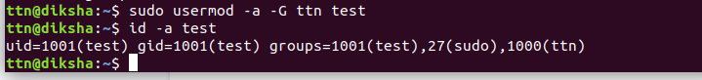

**7.Lock this user.**

**Ans:**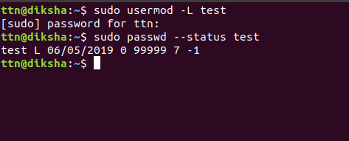

**8.Give this user full access (without password).**

**Ans:**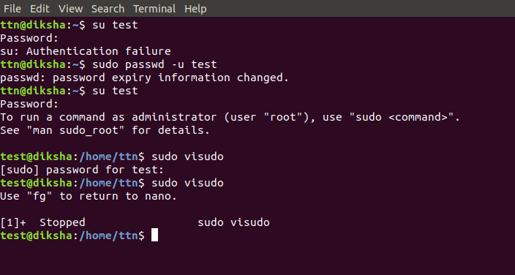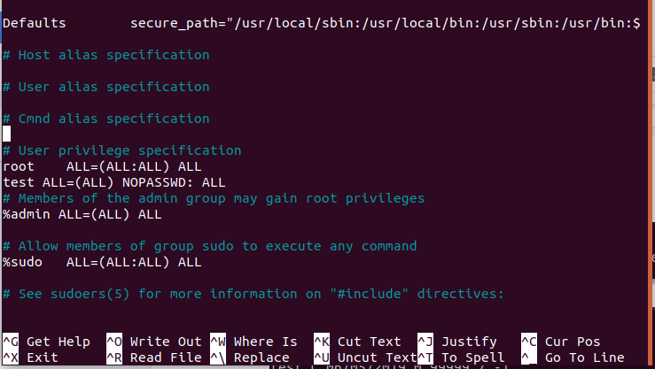

**9.Delete the create user after taking backup of it home directory.**

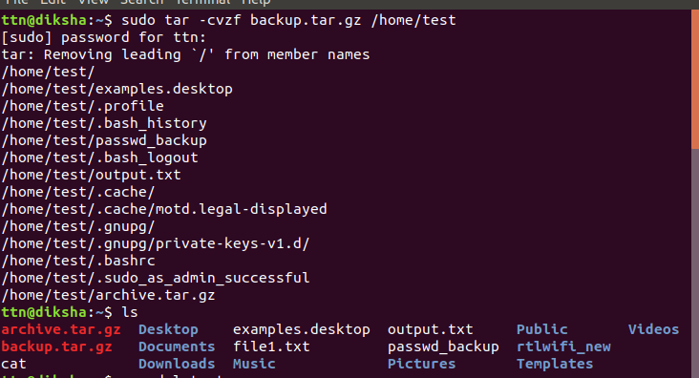



**10.Create a file with some content. Change all lower case letter to upper case letter and save output to another file using redirections.**

**Ans:**

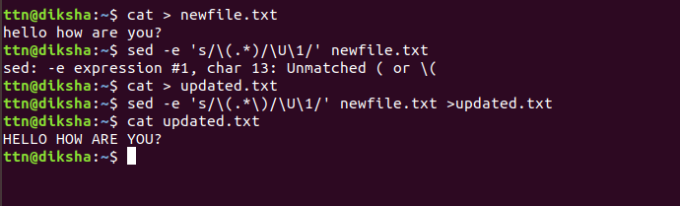

**11.Set nice value of a process to -1.**

**Ans:**

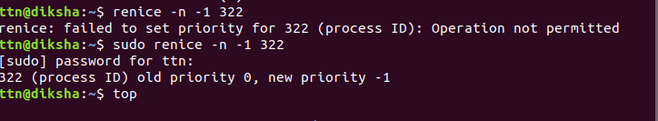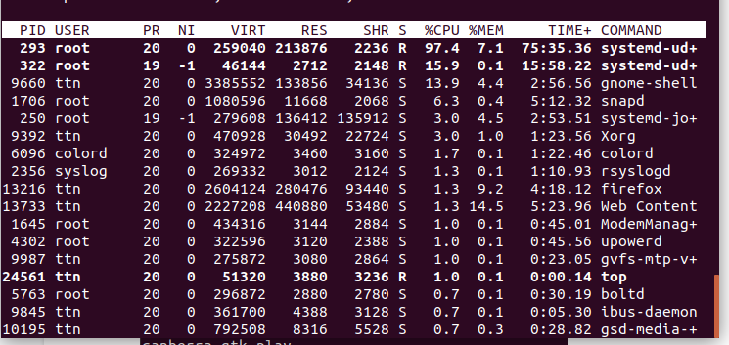

**12.Get list of all files used by “telnet”.**

**13.Check if port 22 is listening using netstat and telnet command.**

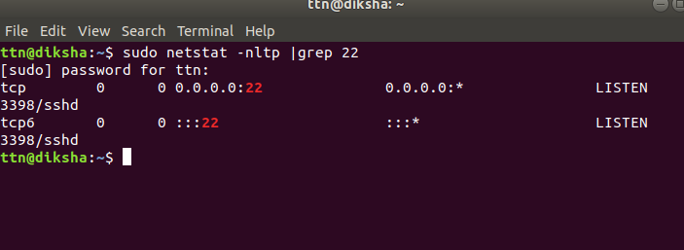

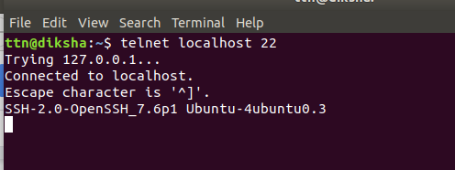

**14.Create a cron job which runs once in a week at 23:45.**

**Ans:** Type command

$crontab -e

45 23 * * 1